NEPAL COLLEGE OF INFORMATION TECHNOLOGY
Balkumari, Lalitpur
Affiliated to Pokhara University

LAB REPORT FOR EMBEDDED SYSTEMS


LAB REPORT 1: VHDL CODE (OR & AND GATE)

Submitted by: Submitted to:
Name: Arpan Adhikari Er. Simanta Kasaju
Roll No.: 231309
BE-CE (5th SEM)

S. N | LAB TOPIC | DATE | REMARKS
1. | VHDL Code (OR & AND Gate) | 20th Nov

LAB 1: VHDL CODE (OR & AND GATE)

OBJECTIVE:
- To write and simulate VHDL code for basic logic gates (AND gate and OR gate).
- To understand the structure of VHDL (Entity and Architecture).
- To verify the truth table of AND and OR gates using simulation.
THEORY:

VHDL (Very High-Speed Integrated Circuit Hardware Description Language) is a hardware description language used to model and simulate digital circuits. It allows us to describe the behavior and structure of digital logic components.

1. AND Gate
An AND gate outputs 1 only when all its inputs are 1.
- Boolean expression:
[
Y = A * B
]
- Truth: Both inputs must be HIGH → output HIGH.

2. OR Gate
An OR gate outputs 1 when any one or more inputs are 1.
- Boolean expression:
[
Y = A + B
]
- Truth: At least one input HIGH → output HIGH.

3. VHDL Structure
Every VHDL program has two main parts:
- Entity – Defines the input and output ports of the circuit.
- Architecture – Describes the behavior or structure of the circuit.
In this practical, VHDL is used to define:
- Entity with inputs (A, B) and output (Y).
- Architecture using logical operators:
  - and for AND gate
  - or for OR gate
Simulation verifies the working by checking if output matches the truth table for all input combinations.

VHDL CODE FOR OR GATE:

library IEEE;
use IEEE.Std_logic_1164.all;
Entity ArpanOrGate is
port (
A, B : in Std_logic;
C: out Std_logic
);
end ArpanOrGate;
Architecture ArchOrGate of ArpanOrGate is
begin
C <= A or B;
end ArchOrGate;

Waveform for OR gate:

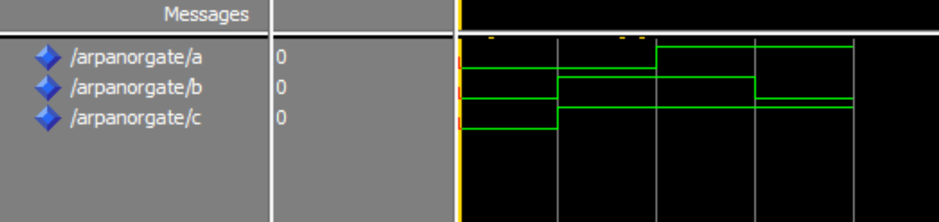

VHDL CODE FOR AND GATE:

library IEEE;
use IEEE.Std_logic_1164.all;
Entity ArpanAndGate is
port (
A, B : in Std_logic;
C: out Std_logic
);
end ArpanAndGate;
Architecture ArchAndGate of ArpanAndGate is
begin
C <= A and B;
end ArchAndGate;

Waveform for AND gate:

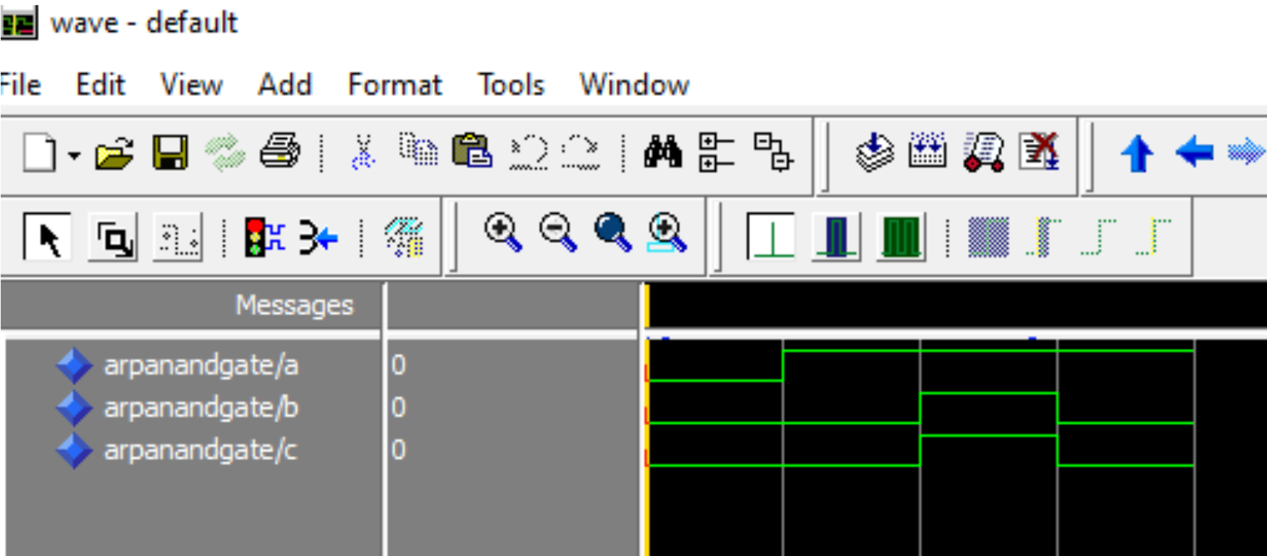

RESULT:

The VHDL code for AND and OR gates was successfully compiled and simulated.
The output waveforms obtained during simulation matched the expected truth tables of both gates.
Specifically, the waveforms clearly showed:
- AND gate output was HIGH only when both inputs were HIGH.
- OR gate output was HIGH when any one input was HIGH.
Thus, the simulated waveforms behaved exactly according to the logical behavior of AND and OR gates.

CONCLUSION:

In this practical, we implemented and simulated the basic logic gates (AND and OR) using VHDL.
The simulation results verified that VHDL effectively models digital circuits, and the output waveforms confirmed the correct functioning of the gates.
This experiment helped us understand VHDL structure (entity and architecture) and how logical operations are described and tested in HDL environments.

